**“Cuddles” World optometry day celebration 23rd march 2019**

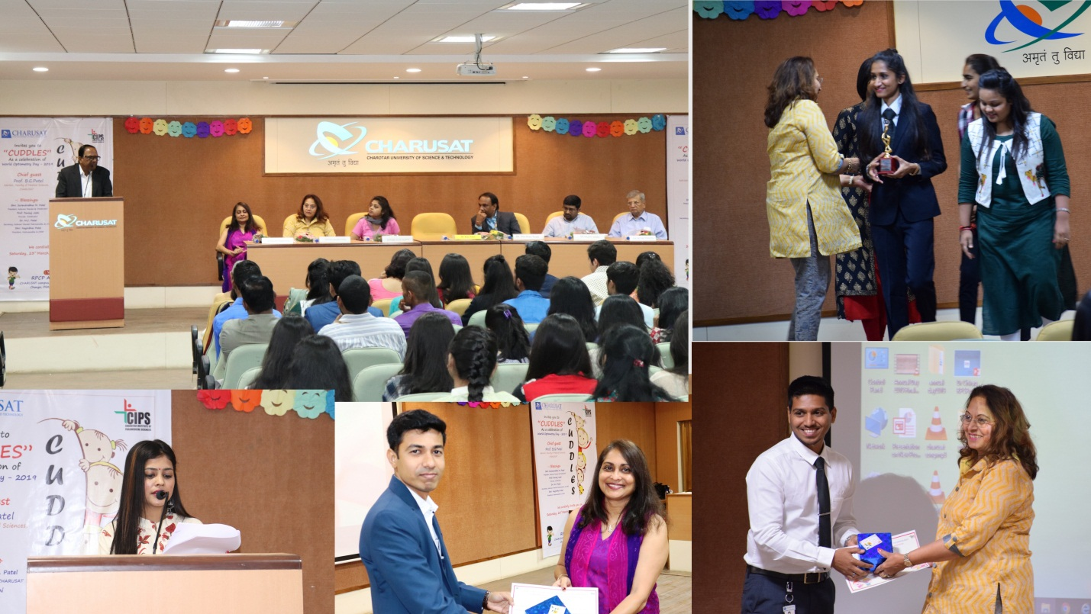

**Opening remarks by Dr.B G Patel/Token of appreciation towards experts**